

**Submitted by:**

Burhan Baig

**Referred to:**

Sir. Muhammad Affan

**Roll no:**

460945

Fundamentals of Programming

Lab Manual 8

TASK 1

int main () {

int average,Sum=0;

int ave[5];

cout<<"Enter 5 values for the array: "<<endl;

for (int i=0; i<5; i++) {

cin>>ave[i];

Sum+=ave[i];

}

average=Sum/5;

cout<<"The average of the terms entered is: "<<average<<endl;

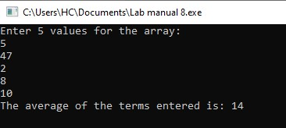return 0;

}

TASK 2

int main() {

int Sortarray[5];

cout <<"Enter 5 terms for sorting: " <<endl;

for (int i=0;i<5;i++)

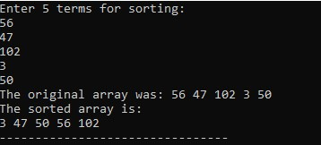 cin>>Sortarray[i];

cout<<"The original array was: ";

for (int j=0;j<5;j++)

cout<<Sortarray[j]<< " ";

for (int i=0;i<5-1;i++) {

for (int j=0;j<5-i-1;j++ ) {

if (Sortarray[j]>Sortarray[j+1]) {

int Temp=Sortarray[j];

Sortarray[j]=Sortarray[j+1];

Sortarray[j+1]=Temp;

}

}

}

cout<<"\nThe sorted array is: "<<endl;

for (int i=0;i<5;i++) {

cout<<Sortarray[i]<< " ";

}

return 0;

}

TASK 3

int main () {

int size=5;

int array[size], midvalue=0;

cout<<"Enter 5 terms for the array: "<<endl;

for (int k=0;k<5;k++) {

cin>>array[k];

}

for (int i=0;i<size;i++) {

midvalue=array[i];

for (int j=i;j<size;j++) {

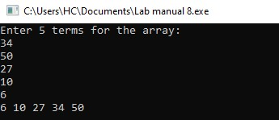if (midvalue>array[j]) {

midvalue=array[j];

array[j]=array[i];

array[i]=midvalue;

}

}

cout<<array[i]<<" ";

}

return 0;

}